Visual Analytics Toolkit (a.k.a. CommonGIS) installation instruction

Installation of the local variant of the system
In order to install the local variant of the V-Analytics system, you should first extract the content of the provided archive with the system to some empty directory on your computer. Ensure that the directory structure of the archive is preserved. If you unpacked the archive correctly, your directory will have the following content:
- Java classes: v-analytics-all-java6.jar. This archive contains the V-Analytics system and all libraries it requires for its work;
- batch files (having extension *.bat and *.sh) starting the system (complete UI and student UI) and trajectory preprocessor;
- Subfolder jre6 with Java 6 runtime environment.
- Optionally, subdirectory “other data” containing data for a few example V-Analytics projects (in further subdirectories).
The system has been checked on Windows machines with Windows 7 64bit operation system.
You may need to edit the provided batch files. The main file StudentUI-java6.bat contains a command line that looks like follows:
jre6\bin\java -Xms1024m -Xmx16g -Dsun.java2d.accthreshold=10 -cp v-analytics-all-java6.jar esda_main.RunStudentUI %*
pause
A similar .sh file for MAC users is included in the distribution. However, the system is not tested on MAC and we can’t guarantee its complet functionality.
The meaning of each command line item is explained in the table below. The table also explains which items must be changed and how.

java | Java interpreter. As new versions of Java (JDK 7 and 8) have serious problems with rendering AWT graphics, we include Java 6 runtime environment to the system distribution
-mx16g | An optional parameter defining how much virtual memory will be available for the Java application. If you are not going to work with large volumes of data, you may remove this item. At Windows 7 64bit operation system you can increase these values for allocating more memory to Java.
%1  e.g.  data/eu/eu.app | This is an optional parameter. If it is absent, the system starts with an empty window. To load data in the system, use File->Load project or File->Load data. If the parameter is present, the system after its start will immediately load the data according to the specification contained in the designated file (in this example –in the file data/eu/eu.app).
To check if everything is installed correctly, please run CommonGISresearch.bat. If Java is installed correctly, main window of the system should appear:
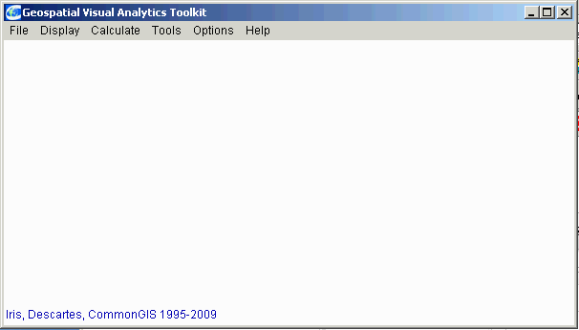
Otherwise, check error messages in CMD window. If this window disappears, remove “rem” from the last line of the batch file “rem pause” and run it again. A possible failure may be caused by too large value of –mx parameter that specifies amount of memory available to Java.
To check Java3d functionality, load project storks.app (File – Load project) and then display space-time cube (Display – Space-Time Cube). The result should be like:
